# **Social Media Analytics Dashboard**

Submitted by: Mohammad Al Sobbahi  
Youssef Dawood  
Nourzahraa Mesmar



Department of Computer Science

**Lebanese University - Section 1 - Hadath**

March 2025

**Table of Contents**

**Social Media Analytics Dashboard** 1

**Table of Contents** 2

**Overview** 3

**Pipeline** 3

**I.** **Data Collection** 5

**II.** **Data Preprocessing** 6

**III.** **Exploratory Data Analysis (EDA)** 8

**IV.** **Social Media Indicators Preparation** 8

**V.** **Data Visualization** 9

**1.** **Followers per Platform** 9

**2.** **Engagement Metrics (Likes, Comments, Shares)** 10

**3.** **Most Active Days** 10

**4.** **Traffic Analytics (Engagement by Platform)** 11

**5.** **Engagement Heatmap** 11

**6.** **Likes and Reactions Over Time** 12

**7.** **Posts Distribution by Content Type** 12

**8.** **Social Shares Over Time** 13

**9.** **Engagement Across Platforms** 14

**10.** **Engagement Type Distribution** 14

**11.** **Followers Gained/Lost** 15

**12.** **Follower Growth Rate** 16

**13.** **Impressions by platform** 16

**14.** **Post Reach Distribution by platform** 17

**15.** **Top 10 Liked Posts** 18

**16.** **Top 10 Shared Posts** 18

**17.** **Best Time to Post** 19

**18.** **Sentiment Score by Platform** 20

**Conclusion** 21

**Future Directions** 22

**GitHub Repository** 22

**References** 22

# **Overview**

Social media plays a vital role in business, education, politics, and personal communication, making it essential to analyze and interpret user engagement and content performance. A social media analytics dashboard is a powerful tool that helps users track key metrics, understand trends, and make data-driven decisions.

This project focuses on building a user-friendly dashboard that aggregates and visualizes data from Facebook, Instagram, and YouTube. The dashboard provides insights into engagement, growth, reach, content performance, and sentiment analysis, making it valuable for businesses, educators, and individuals alike.

# **Pipeline**

The pipeline serves as the backbone of the system, ensuring that social media data is processed efficiently and effectively to derive meaningful insights. Each phase of the pipeline is carefully designed to handle the complexity and scale of social media data, which often includes vast amounts of text, images, and engagement metrics. By leveraging advanced data processing techniques, the system is able to transform raw data into actionable insights, enabling users to gain a comprehensive understanding of social media trends, sentiments, and engagement.

The Data Collection phase pulls in posts, comments, likes, shares, and other relevant engagement metrics from various social media platforms. This raw data often requires preprocessing to address inconsistencies, missing values, or irrelevant content, which is handled in the Data Preprocessing phase. Once cleaned, the data is ready for deeper exploration during the Exploratory Data Analysis (EDA) phase, where users can uncover patterns, trends, and relationships within the data.

Following the EDA, key social media indicators such as sentiment scores, engagement rates, and user demographics are extracted to provide high-level insights for visualization. The final phase, Data Visualization, brings these insights to life by presenting them in an intuitive and interactive format, allowing stakeholders to make data-driven decisions.

This structured pipeline ensures that the system can handle a variety of social media data, providing a seamless flow from data collection to visualization.

Hence the system follows a structured pipeline for collecting, processing, analyzing, and visualizing social media data. The pipeline consists of the following phases:

1. **Data Collection** – Gathering posts and engagement metrics from social media platforms.
2. **Data Preprocessing** – Cleaning and structuring the data to ensure consistency.
3. **Exploratory Data Analysis (EDA)** – Examining data distributions and patterns.
4. **Social Media Indicators Preparation** – Extracting key insights for visualization.
5. **Data Visualization** – Presenting data through interactive dashboards.

**Fig. 1** provides a visual representation of this pipeline, illustrating the flow from data collection to visualization.

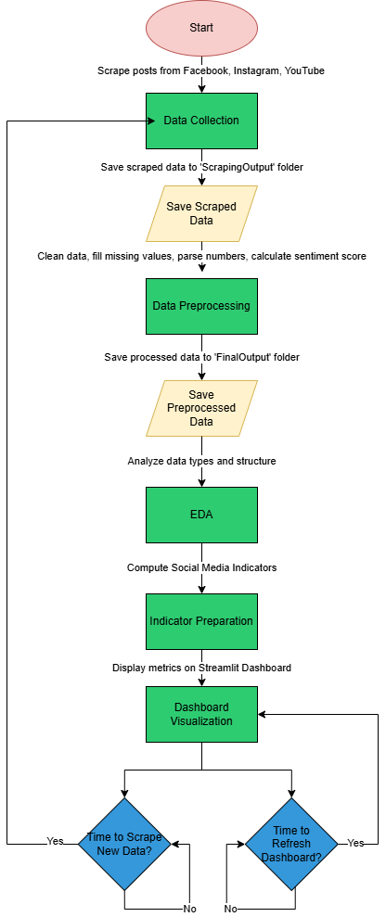  
**Fig. 1.** Social Media Analytics Dashboard Process Flow.

## **Data Collection**

The data collection phase serves as the foundation of the Social Media Analytics Dashboard, ensuring access to the latest and most accurate data from Facebook, Instagram, and YouTube. The primary objective of this phase is to continuously scrape posts and engagement metrics at regular intervals, enabling the dashboard to provide real-time insights into user interactions and content performance.

To achieve this, the project leverages Selenium, a powerful and versatile tool for web scraping. Selenium automates browser interactions, allowing the system to navigate social media platforms, extract data, and handle dynamic content loading. It is particularly well-suited for scraping data from platforms like Facebook, Instagram, and YouTube, which often use JavaScript to render content dynamically.

The scraping process is configured through a centralized constants.py file, which includes essential settings are:

* **Platform URLs:** Links to the Facebook, Instagram, and YouTube pages to be scraped.
* **Authentication Credentials:** Usernames and passwords for logging into Facebook and Instagram.
* **Scraping Intervals:** Defined to ensure data is collected at regular intervals (e.g., every 30 minutes).
* **Scraping Post Count:** The number of posts to scrape per platform per session.

During the scraping process, Selenium logs into the platforms, navigates to the target pages, and extracts key data fields. Each platform contains specific metadata that can be extracted:

* Instagram: Captures posts date, text, likes, followers, and content type (e.g., image, video).
* YouTube: Extracts posts date, text, views, comments, likes, subscriber counts, and content type.
* Facebook: Gathers post text, date, likes, comments, shares, followers, and content type.

The scraped data is stored in structured datasets within the ‘Scraping_Output’ folder, with separate files for each platform. This raw data serves as the input for the subsequent preprocessing phase.

**Fig. 2** provides a visual representation of the sample data collected from Facebook, showcasing fields such as post text, likes, comments, and shares. Similarly, **Fig. 3** illustrates a sample dataset from Instagram, including post text, likes, and content type, while **Fig. 4** displays a sample from YouTube, highlighting views, comments, and subscriber counts.

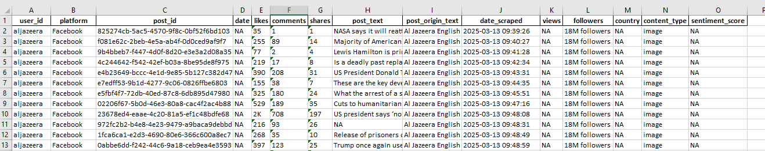

Fig. 2. Sample Scraped Data from Facebook Posts.

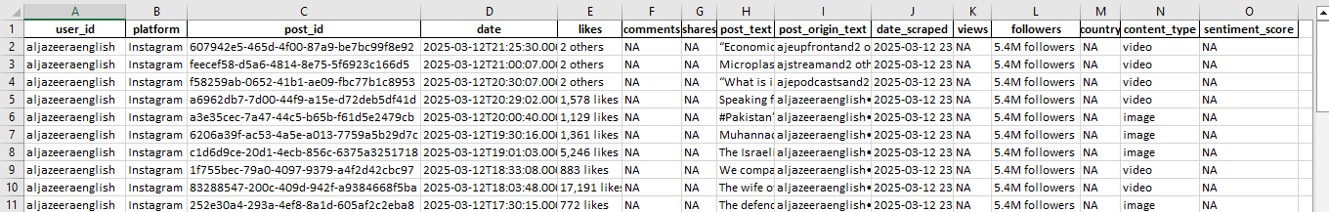

Fig. 3. Sample Scraped Data from Instagram Posts

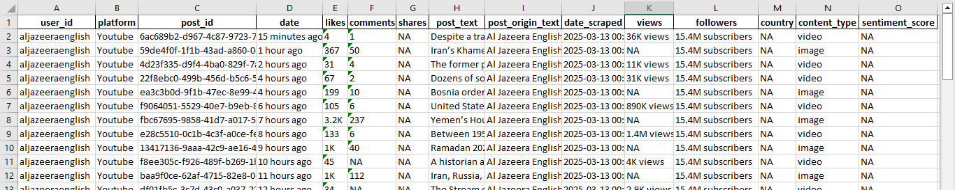

Fig. 4. Sample Scraped Data from YouTube Posts

By leveraging Selenium's capabilities and a well-defined configuration, the data collection phase ensures a steady flow of high-quality data, enabling the dashboard to deliver accurate and up-to-date insights.

## **Data Preprocessing**

The data preprocessing phase is critical for transforming raw, unstructured data into a clean and standardized format suitable for analysis. The primary objective of this phase is to clean, standardize, and enrich the collected data from Facebook, Instagram, and YouTube, ensuring consistency and accuracy for downstream tasks such as exploratory analysis and visualization.

The preprocessing begins with data cleaning, where null values are handled, duplicates are removed, and formatting inconsistencies are corrected. For example, engagement metrics like likes, comments, and shares, which are often represented in formats such as "1K" or "3M," are parsed into numerical values (e.g., 1000 or 3000000). Similarly, relative timestamps like "30 minutes ago" or "1 hour ago" are converted into absolute dates by calculating the difference between the scraped date and the post date.

Next, the data undergoes standardization to ensure uniformity across platforms. This includes aligning column names, data types, and metric formats. For instance, follower counts and engagement metrics are standardized to ensure they can be compared and aggregated seamlessly.

A key component of preprocessing is sentiment analysis, which is performed using TextBlob and NLTK. The sentiment polarity of post texts and comments is calculated to determine whether the sentiment is positive, negative, or neutral. This involves:

* Tokenizing the text and removing stopwords.
* Calculating sentiment scores using TextBlob, where:
  + - 0 indicates neutral sentiment.
    - > 0 indicates positive sentiment.
    - < 0 indicates negative sentiment.

The output of this phase is a refined dataset saved in ‘Final_Output/social_media_posts.xlsx’, which includes cleaned and standardized data from all platforms.

**Fig. 5** provides a detailed table showcasing the column names and descriptions of the values after preprocessing.

|  |  |
| --- | --- |
| Attribute | Details |
| user_id | A unique identifier assigned to each user. |
| platform | The social media platform where the post was made (Facebook, Instagram, YouTube). |
| post_id | A unique identifier assigned to each post. |
| date | The timestamp indicating when the post was published. |
| likes | The total number of likes or reactions received by the post. |
| comments | The total number of comments on the post. |
| shares | The total number of shares or retweets of the post. |
| post_text | The textual content of the post. |
| date_scraped | The date when the post was collected through scraping. |
| views | The total number of views the post received. |
| followers | The number of followers the user had at the time of posting. |
| content_type | The format of the post (image, video, text). |
| sentiment_score | A numerical representation of the post's sentiment ( positive, neutral, negative). |

Fig. 5. Table of Data Model Columns with Descriptions

Additionally, **Fig. 6** provides a sample of the preprocessed data, illustrating how the cleaned and standardized dataset looks after preprocessing. This includes examples of parsed engagement metrics, standardized dates, and calculated sentiment scores.

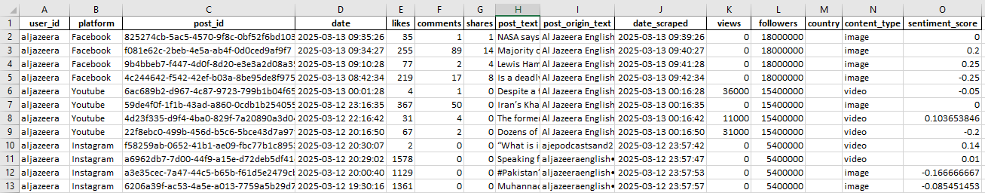

Fig. 6. Sample of Final Preprocessed Data

By meticulously cleaning, standardizing, and enriching the data, the preprocessing phase ensures that the dashboard is built on a solid foundation of high-quality data, enabling accurate and meaningful analysis.

## **Exploratory Data Analysis (EDA)**

The Exploratory Data Analysis (EDA) phase aims to uncover patterns, trends, and insights within the preprocessed data by understanding its distribution, identifying correlations, and analyzing trends across Facebook, Instagram, and YouTube. Key analyses performed include descriptive statistics, such as calculating the mean, median, and variance of engagement metrics like likes, comments, and shares, to understand their distribution and detect outliers. Trend analysis was conducted to evaluate post-performance over time, identifying peak engagement periods and seasonal patterns through time-series charts. Additionally, a comparative analysis was performed to compare platform-wise engagement performance, revealing differences in user behavior and content effectiveness across platforms. To support these analyses, various visualizations were generated, including histograms to show metric distributions, scatter plots to identify correlations, boxplots to analyze variations, and time-series charts to visualize engagement patterns over weeks and months. These insights form the foundation for the dashboard’s visualizations and provide actionable intelligence for optimizing social media strategies.

## **Social Media Indicators Preparation**

The Social Media Indicators Preparation phase focuses on defining and extracting key performance indicators that provide actionable insights into social media performance. These indicators are grouped into five main categories: engagement metrics, growth trends, reach and exposure, content effectiveness, and sentiment analysis.

For engagement metrics, indicators such as average likes, comments, and shares per post are calculated to measure user interaction. Growth trends are analyzed by tracking follower and subscriber growth rates over time, highlighting periods of significant increase or decline. Reach and exposure metrics include total impressions and reach-per-post analysis, which help assess the visibility of content. Content effectiveness is evaluated by identifying top-performing posts based on engagement and reach. Finally, sentiment analysis measures audience perception by computing sentiment scores for each post using NLP techniques like TextBlob, categorizing sentiment as positive, negative, or neutral.

The calculation methodology for these indicators is designed to ensure accuracy and relevance. For example, the engagement rate is calculated as (likes + comments + shares) / total followers, providing a normalized measure of user interaction. Sentiment scores are computed per post by analyzing the text of comments and posts, enabling a deeper understanding of audience perception. These prepared indicators serve as the foundation for the dashboard’s visualizations, empowering users to make data-driven decisions and optimize their social media strategies.

## **Data Visualization**

The data visualization phase focuses on developing an interactive dashboard that provides real-time analytics and insights into social media performance. The dashboard is built using the Streamlit framework for an intuitive user interface, with visualizations powered by libraries like Plotly and Matplotlib.

The dashboard features include:

* **Real-time Metrics:** Automatically updates every 30 minutes with the latest scraped data.
* **Customizable Filters:** Users can filter data by platform, date range, and engagement type.
* **Key Visualizations:** A variety of charts and graphs to display insights effectively.

Below is a detailed explanation of each indicator, its importance, calculation methodology, and visualization:

### **Followers per Platform**

This indicator tracks the**audience growth**and**platform popularity** by calculating the total number of followers for each platform. It is essential for understanding which platform is most effective for reaching the target audience. The calculation involves grouping the data by platform and extracting the maximum follower count for each platform. The values are formatted for readability (e.g., converting 1000 to "1K"). The results are displayed as **cards**, as shown in **Fig. 7**, which illustrates the follower distribution across Facebook, Instagram, and YouTube.

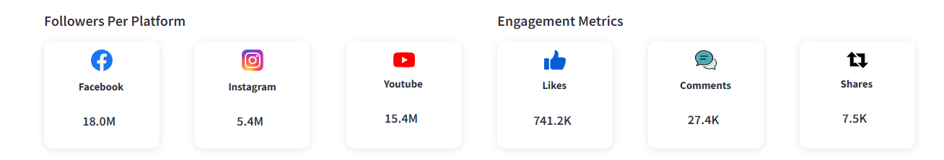

Fig. 7. Followers per Platform Indicator

### **Engagement Metrics (Likes, Comments, Shares)**

Engagement metrics measure user interaction with content, providing insights into the effectiveness of posts and campaigns. The total number of likes, comments, and shares is summed up across all posts, and the values are formatted for readability (e.g., converting 1000 to "1K"). These metrics are displayed as cards, as shown in **Fig. 8**, which provides a quick overview of user engagement.



Fig. 8. Engagement Matrices Indictor

### **Most Active Days**

This indicator identifies the best days for posting by analyzing the number of posts published each day. It helps optimize content scheduling strategies to maximize engagement. The calculation involves grouping posts by day and counting the number of posts per day. The results are displayed as a bar chart, as shown in **Fig. 9**, which highlights the most active days for posting.

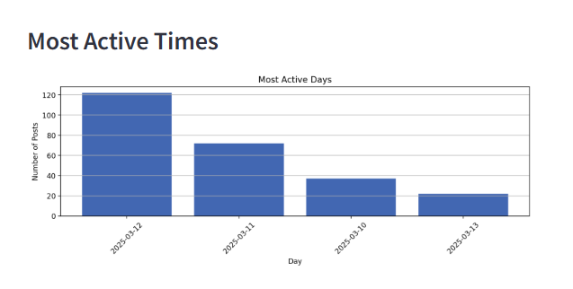

Fig. 9. Most Active Time Indicator

### **Traffic Analytics (Engagement by Platform)**

Traffic analytics highlight which platform drives the most engagement, helping allocate resources effectively. The total engagement (sum of likes, comments, and shares) is calculated for each platform, and the percentage of total engagement per platform is computed. The results are displayed as a pie chart, as shown in **Fig. 10**, which visualizes the distribution of engagement acrossplatforms**.**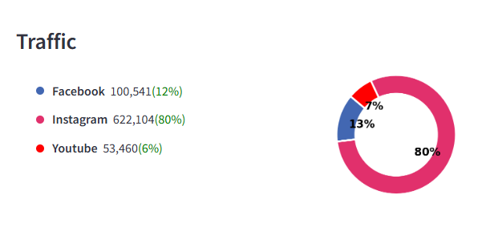

Fig. 10. Data Traffic Indicator

### **Engagement Heatmap**

The engagement heatmap visualizes engagement patterns over time and across platforms, helping identify peak engagement periods. The calculation involves aggregating engagement (likes + comments + shares) by platform and day and pivoting the data to create a heatmap matrix. The results are displayed as a heatmap, as shown in **Fig. 11**, with platforms on the y-axis, days on the x-axis, and engagement intensity represented by color.

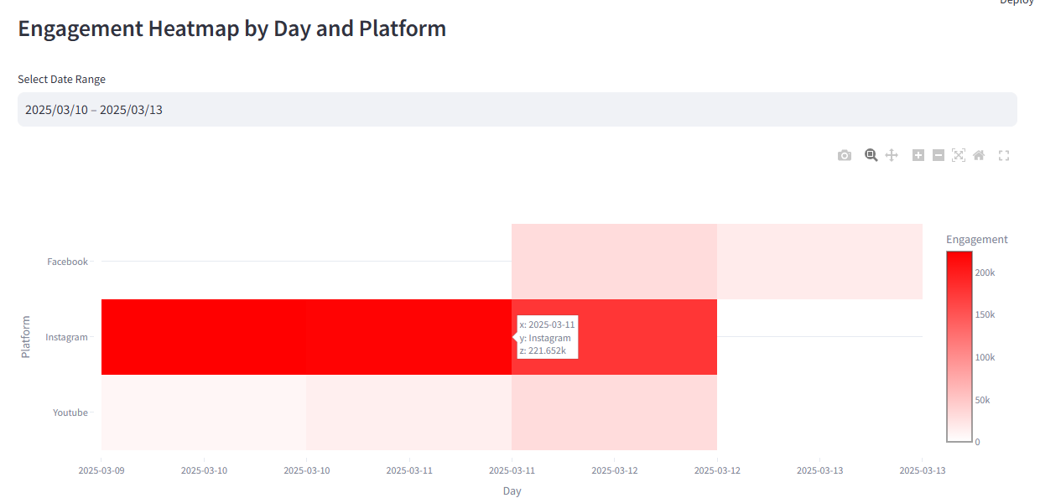

Fig. 11. Engagement Heatmap by Day and Platform

### **Likes and Reactions Over Time**

This indicator tracks the performance of posts over time, helping identify trends and seasonal patterns in user engagement. The calculation involves summing up likes and comments by month and platform and computing total interactions (likes + comments) for each platform. The results are displayed as a line chart, as shown in **Fig. 12**, which illustrates trends in likes and reactions over time.

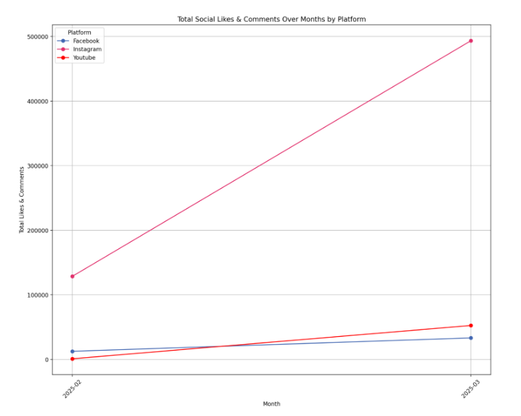

Fig. 12. Total Social Likes & Comments Over Months by Platform

### **Posts Distribution by Content Type**

This indicator identifies which content types (e.g., images, videos, text) perform best, helping tailor content strategies to audience preferences. The calculation involves grouping posts by content type and counting the number of posts per type. Percentages are computed to show the distribution. The results are displayed as a pie chart, as shown in **Fig. 13**, which visualizes the percentage of posts by content type.

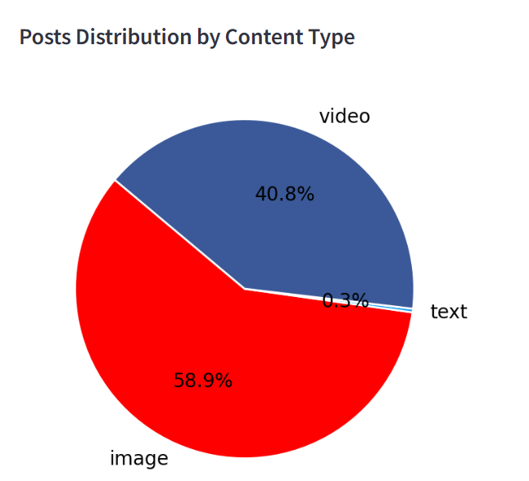

Fig. 13. Post Distribution by Content Type

### **Social Shares Over Time**

This indicator measures the virality of content, helping identify which posts resonate most with the audience. The calculation involves summing up shares by month and platform and computing total interactions (shares) for each platform. The results are displayed as a line chart, as shown in **Fig. 14**, which illustrates trends in social shares over time.

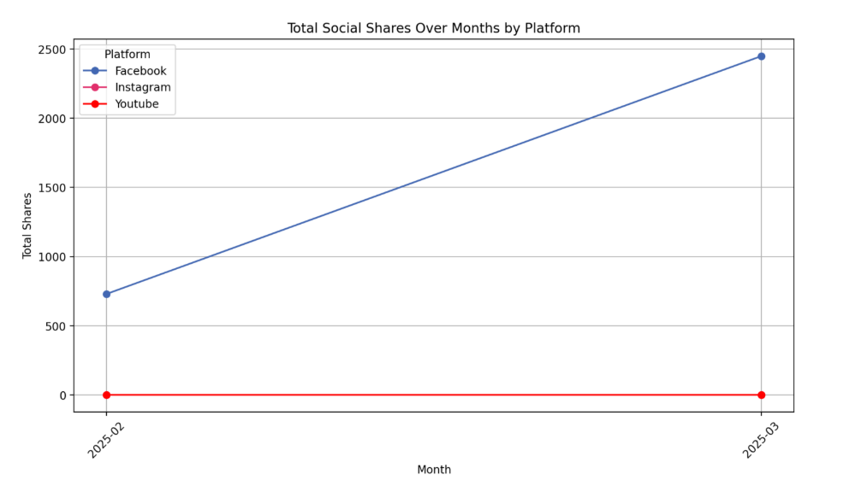

Fig. 14. Total Social Shares Over Months by Platform

### **Engagement Across Platforms**

This indicator visualizes the distribution of engagement types (likes, comments, shares) across different platforms. It helps identify which platform generates the most user interactions and the predominant engagement type on each.

**Calculation Methodology:**

* + Aggregates total likes, comments, and shares per platform.
  + Uses a stacked bar chart to display engagement breakdown.

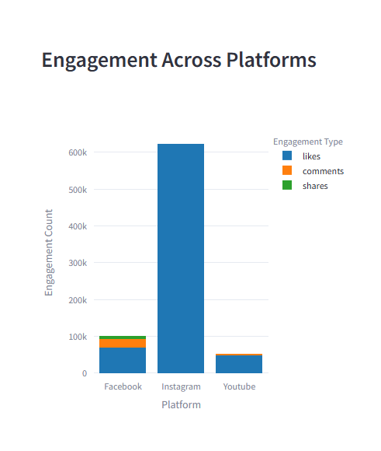

Fig. 15. Engagement Across Platforms

### **Engagement Type Distribution**

The **Engagement Type Distribution** indicator provides valuable insights into user interaction preferences by analyzing the proportion of likes, comments, and shares across all platforms. This helps determine whether users are more inclined to express appreciation through likes, engage in discussions via comments, or amplify content visibility by sharing. Understanding these preferences allows businesses to refine their content strategies by emphasizing the most effective engagement type—whether it be crafting highly shareable posts, encouraging discussions, or focusing on visually appealing content that garners more likes. Additionally, this metric enables businesses to assess the effectiveness of their interaction-driven campaigns, ensuring that engagement efforts align with audience behavior and maximize overall reach and impact.

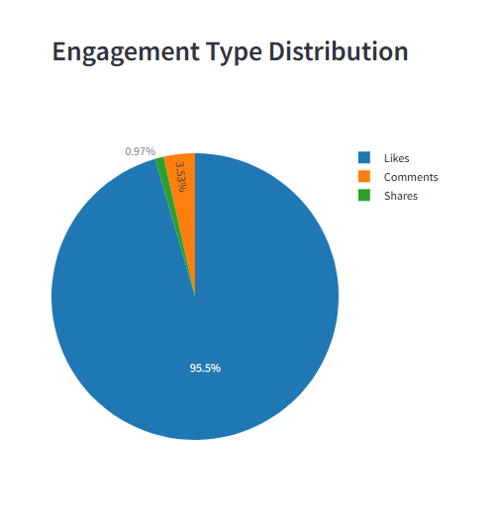

Fig. 16. Engagement Type Distribution

### **Followers Gained/Lost**

The Followers Gained/Lost indicator tracks daily fluctuations in the number of followers, helping businesses and content creators understand trends in audience growth and retention. By analyzing these changes, organizations can identify which actions, campaigns, or content strategies lead to follower increases or losses. Spikes in gained followers may indicate successful promotions or viral content, while sudden drops could signal issues such as negative publicity or ineffective engagement. This insight enables businesses to optimize their social media strategies, retain their audience, and enhance overall brand presence.

**Calculation Methodology:**

* + Filters data by platform and month.
  + Computes the daily difference in follower count.
  + Displays a bar chart where positive and negative changes are color-coded.

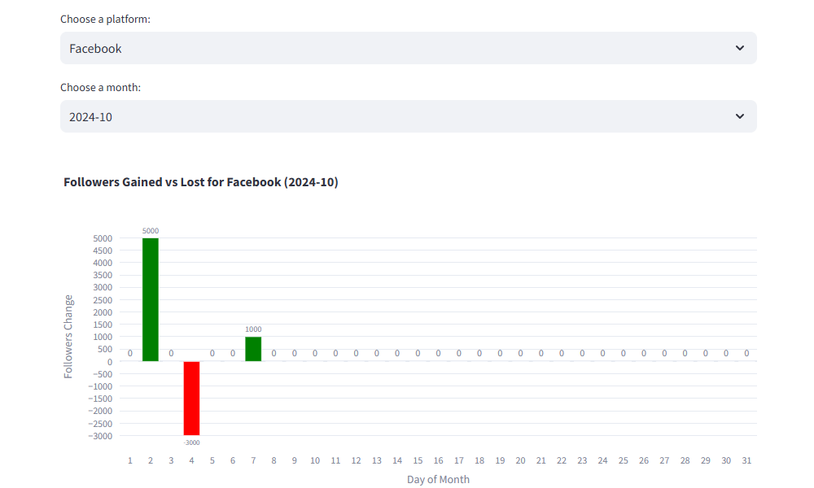

Fig. 17. Followers Gained/Lost

### **Follower Growth Rate**

The Follower Absolute Growth indicator measures the total increase or decrease in followers over a specific period, providing a clear picture of audience expansion across different platforms. By comparing the first and last recorded follower counts, businesses can assess their overall growth trajectory and the effectiveness of their social media strategies. A positive growth trend indicates successful engagement efforts, while stagnation or decline may highlight the need for improved content, better audience targeting, or enhanced interaction strategies. This metric is crucial for evaluating long-term brand visibility and the impact of marketing initiatives on audience retention and acquisition.

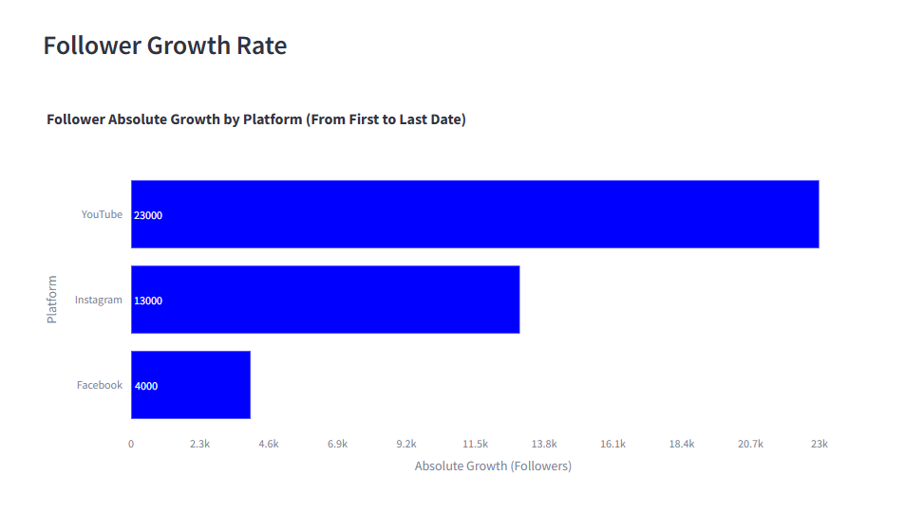

Fig. 18. Followers Growth Rate

### **Impressions by platform**

Total impressions represent the number of times a post has been displayed on users' screens, regardless of whether they engaged with it. This metric provides insights into the reach and visibility of social media content across different platforms.

**Calculation Methodology:**  
For each post, impressions are estimated based on available engagement metrics:

* If views are available (e.g., on YouTube), they are used as the impression count.
* Otherwise, impressions are approximated using the sum of likes, comments, and shares, assuming that posts with higher engagement have a broader reach.
* Total Impressions= { Views, if views are available  
   Likes + Comments + Shares, otherwise }

After calculating impressions for individual posts, the total impressions are grouped by platform to determine which social media channel generates the highest content visibility.

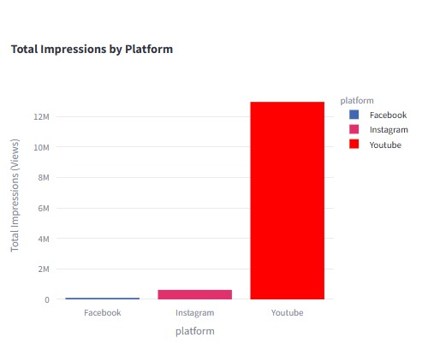

Fig. 19. Total impressions by Platform

### **Post Reach Distribution by platform**

The Posts Distribution by Content Type indicator categorizes and analyzes social media posts based on their format (e.g., image, video, or text). This metric helps determine which type of content is most frequently posted and performs best across different platforms.

**Calculation Methodology:**

* Each post is labeled with its content type (e.g., "image," "video," "text").
* The total number of posts per content type is counted.
* Percentages are calculated to show the proportion of each content type in the dataset.
* Content Type Percentage= (Number of Posts of a type/Total Number of Posts) ×100
* The data is then grouped by platform to compare content preferences across Facebook, Instagram, and YouTube.

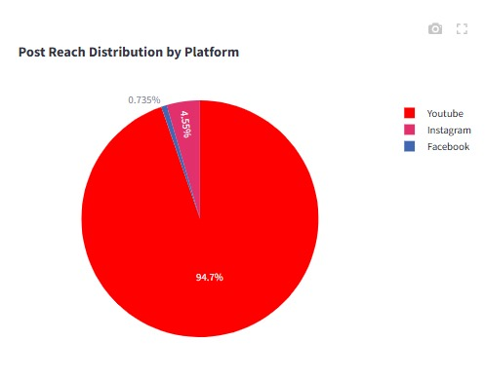

**Fig. 20.** Post Reach Distribution by Platform

### **Top 10 Liked Posts**

The Top 10 Liked Posts indicator identifies the posts that received the highest number of likes across all platforms. Likes serve as a key engagement metric, reflecting audience appreciation and content popularity.

**Calculation Methodology:**

* All posts are sorted in descending order based on their like count.
* The top 10 posts with the highest number of likes are selected.
* Additional details such as post ID, platform, and content type are included for context.
* Top 10 Liked Posts=First 10(Sort(Posts by number of Likes, Descending))

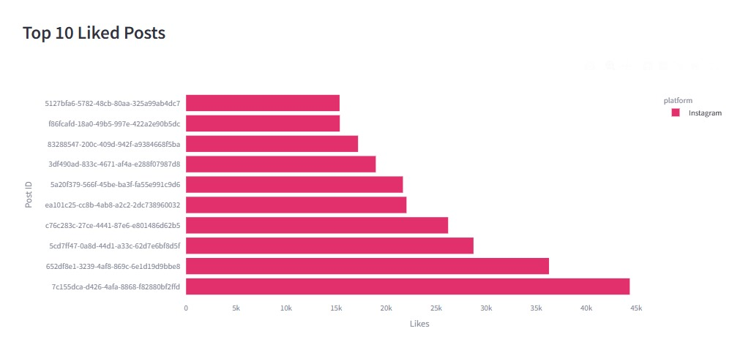

Fig. 21. Top Liked Posts

### **Top 10 Shared Posts**

The Top 10 Shared Posts indicator identifies the posts that received the highest number of shares across all platforms. Shares represent a deeper level of engagement, as users actively distribute the content to their networks, increasing its reach and potential virality.

**Calculation Methodology:**

* All posts are sorted in descending order based on their share count.
* The top 10 posts with the highest number of shares are selected.
* Additional details such as post ID, platform, and content type are included for context.
* Top 10 Shared Posts=First 10(Sort(Posts by number of Shares,Descending))

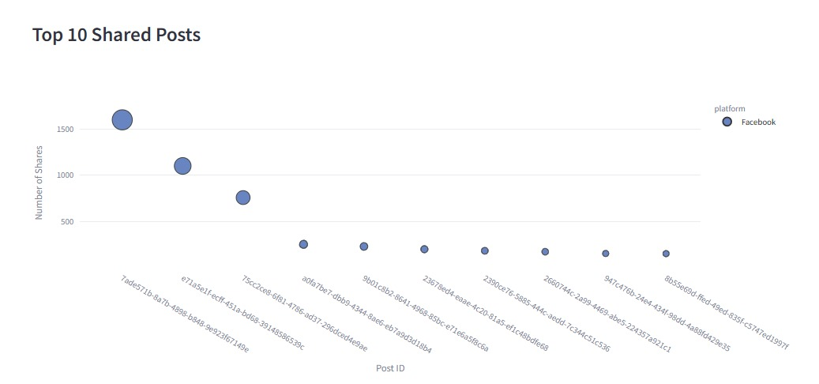

Fig. 22. Top Shared Posts

### **Best Time to Post**

The Best Time to Post indicator analyzes user engagement patterns across different days of the week and hours of the day. This helps determine the optimal posting times to maximize likes, comments, shares, and overall audience interaction.

**Calculation Methodology:**

* Each post’s timestamp is extracted and split into:
  + Day of the week (Monday–Sunday)
  + Hour of the day (0–23)
* Engagement metrics (likes, comments, shares) are aggregated based on these time segments.
* A heatmap matrix is generated, where:
  + The X-axis represents hours (0–23).
  + The Y-axis represents days of the week (Monday–Sunday).
  + The color intensity represents total engagement.
* Total Engagement = Likes+Comments+Shares

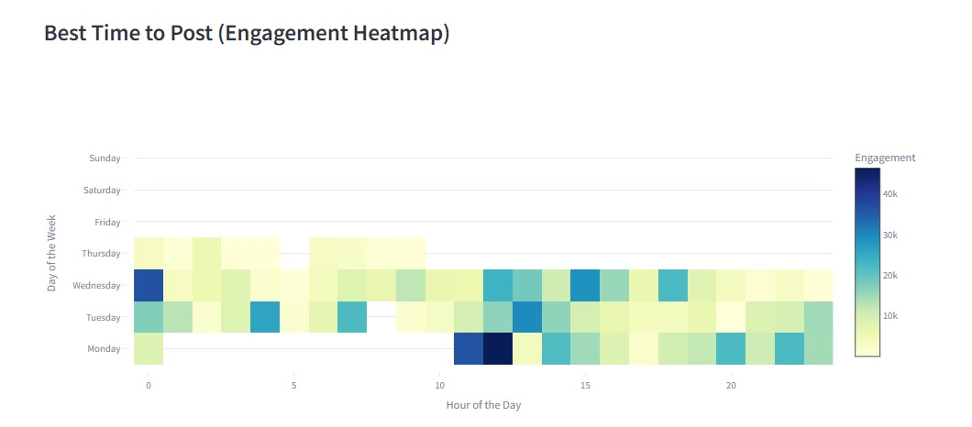

Fig. 23. Best Time to Post Heatmap

### **Sentiment Score by Platform**

The Sentiment Score by Platform indicator measures the overall sentiment (positive, neutral, or negative) of user interactions across different social media platforms. This helps evaluate audience perception and engagement quality.

**Calculation Methodology:**

* Sentiment analysis is performed on post captions and user comments using Natural Language Processing (NLP) techniques (e.g., TextBlob, NLTK).
* Each comment/post receives a sentiment polarity score:
  + > 0 → Positive sentiment
  + = 0 → Neutral sentiment
  + < 0 → Negative sentiment
* The sentiment scores of all comments associated with a post are averaged to determine the overall platform sentiment score.
* The results are grouped by platform to compare sentiment trends.

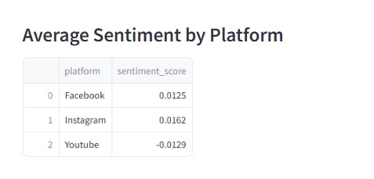

Fig. 24. Average Sentiment Score by platform

**Dashboard Execution and Data Update Flow**

The system follows a structured workflow to ensure continuous data collection, processing, and visualization. On the first run, the dashboard initializes as shown in **Fig. 25**, and the scraper starts collecting data from social media platforms. Once the scraping process is completed, the dashboard loads and becomes fully interactive as shown in **Fig.26**.

The dashboard refreshes every 15 minutes to reflect the latest processed data. Simultaneously, the scraper runs in the background every 30 minutes to fetch new social media data. Once the scraping process is completed, data preprocessing steps are executed, ensuring data is cleaned and structured before being saved. This cycle repeats continuously, ensuring the dashboard remains up to date with the latest insights.

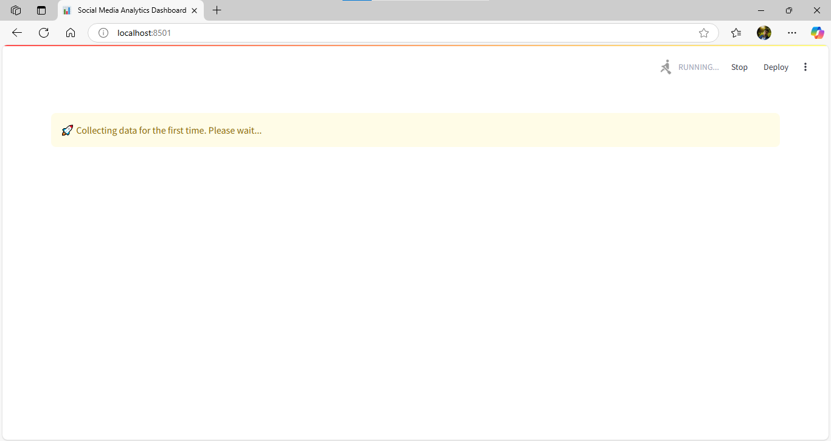

Fig. 15. Initial Dashboard View on First Run

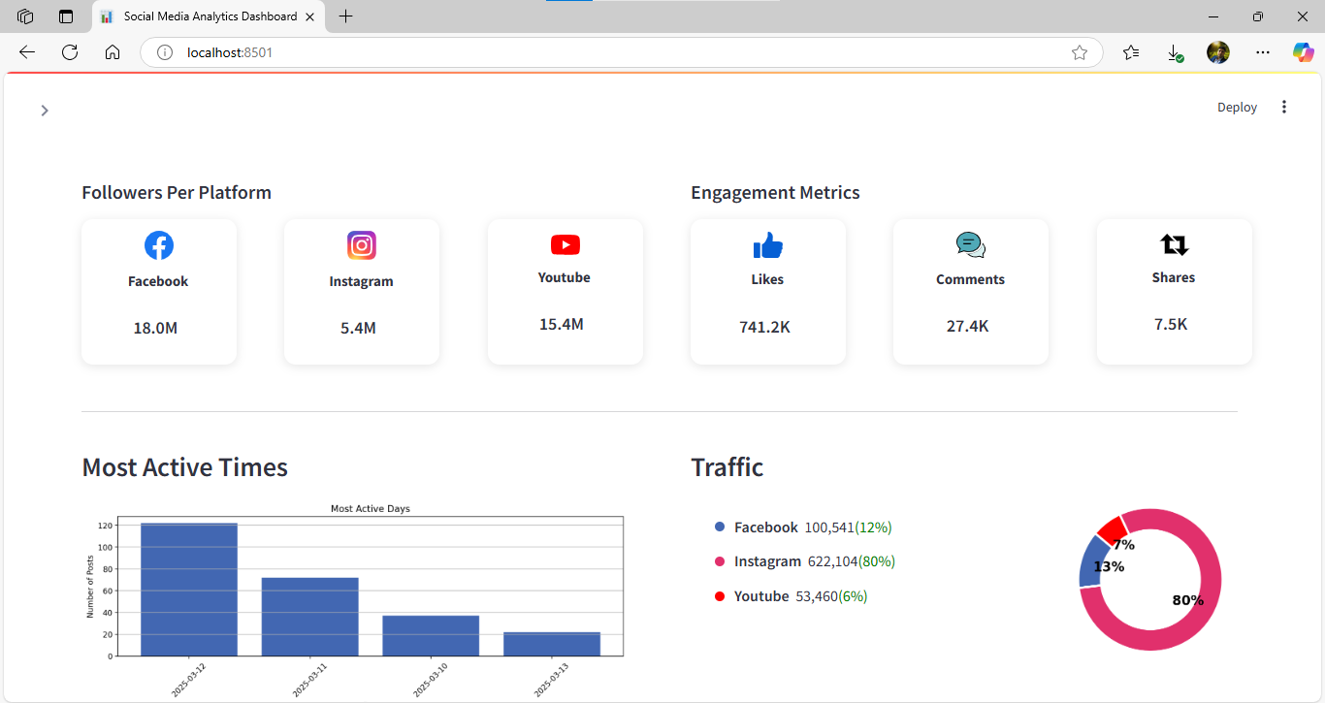

Fig. 16. Fully Interactive Dashboard After Data Loading

# **Conclusion**

This project successfully developed an automated Social Media Analytics Dashboard, providing real-time insights into engagement trends across Facebook, Instagram, and YouTube. By leveraging web scraping, data processing, and visualization techniques, the dashboard empowers businesses and content creators to optimize their strategies and enhance audience interaction.

# **Future Directions**

The Social Media Analytics Dashboard lays a strong foundation for monitoring and analyzing social media performance across multiple platforms. However, there are several opportunities to enhance its functionality, scalability, and user experience. Below are some proposed future directions for the project:

1. **Expand Platform Support:** Integrate Twitter, LinkedIn, and TikTok analytics to provide a more comprehensive view of social media performance.
2. **Advanced Sentiment Analysis:** Utilize deep learning models (e.g., BERT, LSTM) for more accurate and nuanced sentiment classification.
3. **Predictive Analytics:** Implement machine learning models to predict engagement trends and optimize content strategies based on historical data.
4. **Enhanced User Interface:** Develop mobile-friendly dashboard versions with enhanced interactivity and customization options.

These improvements will not only broaden the dashboard's applicability but also make it a more powerful tool for users across various domains.

# **GitHub Repository**

The complete source code, datasets, and detailed documentation for the Social Media Analytics Dashboard project are available on GitHub. You can access the repository at:

* [Social-Media-Analytics-Dashboard](https://github.com/mohammdsobbahi2001/Social-Media-Analytics-Dashboard) (main branch).

Additionally, the steps for running the code are outlined in the [README file](https://github.com/mohammdsobbahi2001/Social-Media-Analytics-Dashboard?tab=readme-ov-file#readme-ov-file) within the repository.

# **References**

1. M. Trunfio and S. Rossi, "Conceptualising and measuring social media engagement: A systematic literature review," *Italian Journal of Marketing*, vol. 2021, pp. 267–292, Aug. 2021.
2. L. Williams, E. Anthi, and P. Burnap, "Uncovering key factors that drive the impressions of online emerging technology narratives," *School of Computer Science & Informatics, Cardiff University*, Cardiff, UK.
3. F. Poeczea, C. Ebster, and C. Strauss, "Social media metrics and sentiment analysis to evaluate the effectiveness of social media posts," *Proc. 9th Int. Conf. Ambient Syst., Networks, and Technol. (ANT 2018)*, pp. 1-6, 2018.